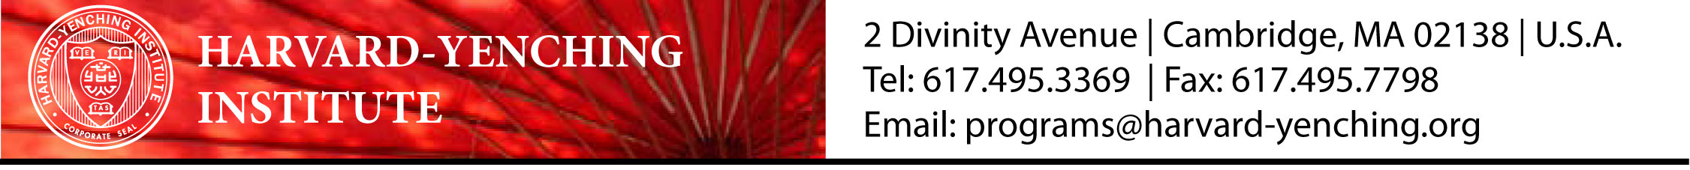
HYI Fellowship Programs  2014-2015 Institutional Approval Form | To be signed by the President, Vice-Chancellor, Rector, Dean of Faculty or other appropriate administrative officer of the applicant’s sponsoring university in Asia.  Application is incomplete without approval.

We approve and recommend the application of for a Harvard-Yenching Institute fellowship. This university will grant the above-named faculty member/doctoral student a suitable leave of absence if he or she is awarded the fellowship.

Signed:

Title:

Date:

