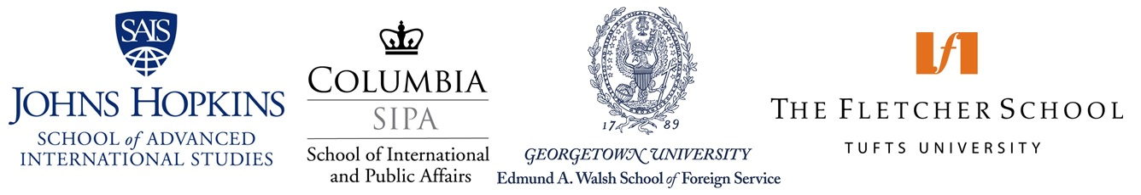

You are invited!

“Pursuing a Professional Graduate Degree in International Affairs”

Join admissions representatives and alumni from graduate schools of international affairs who will be available to talk about degree offerings, career & networking opportunities as well as admissions requirements. A question and answer will follow after a brief presentation by admissions representatives. Institutions in attendance will include: Columbia University School of International and Public Affairs, Georgetown University Edmund A. Walsh School of Foreign Service, Johns Hopkins University School of Advanced International Studies, and Tufts University Fletcher School of Law and Diplomacy. Students from all academic disciplines are welcome to attend.
2nd Conference Room, 2nd Floor, Administration Building
Division of International Cooperation
Office of Global Affairs
National Tsing Hua University
Hsinchu, Taiwan

Friday, November 13, 2015
10:40am-11:50am

For more information please contact Ms. Shin-Yi Chen in the Office of Global Affairs at chensy@mx.nthu.edu.tw.

