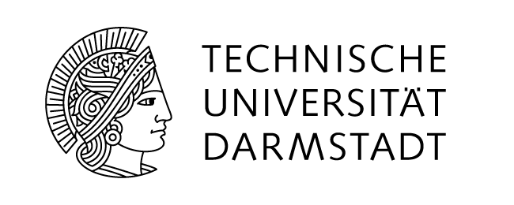

International Summer School 2018

at Technische Universität Darmstadt, Germany

German Engineering and Language July 01 to July 28, 2018

Application

Personal Details
Last Name
First Name(s)
Gender
Date of Birth | DD/MM/YYYY
Address
Country
E-Mail*
Home Institution
Field of Study
Current Year
German language level
Emergency Contact | Name and telephone number

*We will email acceptance letters/payment confirmation and relevant information to this email address. Please, keep us updated of any change:

Attachements
Please add the following documents:
- Copy of a valid identity document (Passport)
- CV
- Transcript of Records (unofficial)
- Motivation Letter (max. one page)
- Why do you want to do the International Summer School Programme: German Engineering and Language?
- What are your expectations regarding your academic engineering interests?

Please send the nomination form until April 04, 2018
to summer@pvw.tu-darmstadt.de

