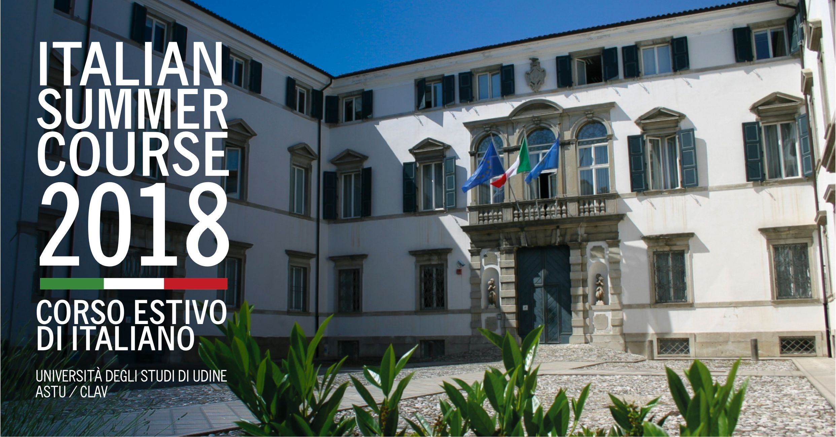

Italian Summer Course 2018
"Intensive Language and Culture"
03rd July – 21st July 2018

The International Relations and Mobility Office of the Student Services Area (ASTU) of the University of Udine, in cooperation with the Linguistic Centre of the University of Udine (CLAV), supported by ARDISS (Agenzia Regionale per il Diritto agli Studi Superiori) and ALEF (Associazione Lavoratori Emigrati del Friuli Venezia Giulia), organizes the “Italian Summer Course 2018”, that will take place at the University of Udine (Italy), from the 03rd July to the 21st July 2018.

LEVELS AND TEACHING GOALS

In order to assess their current level of Italian, Participants will take a placement test at the beginning of the Course. It will consist in a written and oral test. At the end of the course a frequency and proficiency certificate will be issued to those who have shown regular attendance and progress.

Intermediate
At the end of the course, Participants will be able to deal with everyday social situations and describe events using their past, present and future experiences. They will be able to understand clear and short texts on cultural topics. They will produce simple connected text on topics which are familiar or of personal interest and clear formal text.

Advanced
At the end of the course, Participants will be able to understand everyday language in any interpersonal and social situation, real and audio-visual texts. They will be able to express their feelings and explain a viewpoint, differentiating finer shades of meaning and using well-structured, detailed text on complex subjects.

Maximum number of Participants per class
10-12.

Teaching method
Teachers will follow a communicative-functional approach, in order to develop the four basic language skills both separately and as a whole. At the beginning of the course a careful analysis will be carried out to evaluate the students’ special needs and interests.

Teaching material
Teaching materials include a Handbook of Italian as a foreign language for each level, audio-visual and written material taken from various sources will be also used.
A full programme will be given to Participants at the beginning of the course.

Credits
The course awards n.6 credits (CFU – Crediti Formativi Universitari).

Duration of course
The course is 60 hours long; 4 hours a day, from Monday to Friday. Weekends will be free.
As part of the 60 hours teaching “Workshop activities” are planned for all levels.
Besides 60 hours the course includes:

- a guided tour of Udine;
- a guided trip of an historical site in Friuli Venezia Giulia;
- 4 seminars of “Italian Culture”.

Contacts
University of Udine
Student Services Area (ASTU)
International Relations and Mobility Office
8, Via Palladio - I-33100 - Udine (UD) - Italy

- Alessia Bruno
e-mail: alessia.bruno@uniud.it
voice.:+39 0432 556497 fax: +39 0432 556496

- Massimo Plaino
e-mail: massimo.plaino@uniud.it
voice:+39 0432 556218 fax:+39 0432 556496

Italian Summer Course 2018:
www.uniud.it/en/uniud-international/incoming-exchange-students/ISC

Course fees
€ 600,00

The Fee includes

- lessons;
- the tutorial service;
- the use of the Linguistic Centre of the University of Udine (CLAV), the use of the Library and the use of the Computer room;
- trips;
- Italian seminars;
- one daily meal (price € 5,00) offered at the University canteen (ARDISS Udine);
- other activities, as specified in the programme.

The Fee does not include

- accommodation;
- one daily meal (price € 5,00, ARDISS Udine);
- textbooks.

Enrolment
Please fill in and send back the enclosed card.
The registration fee of € 400,00 (plus bank charges) can be paid to:

University of Udine
Bank "UNICREDIT s.p.a."
IBAN IT 23R0200812310000040469443
SWIFT CODE UNCRITM1UN6
CIN R
ABI 02008
CAB 12310
Account n. 000040469443
Specify: “Italian Summer Course”

Please include full name and address. Send us notice of the payment and the copy of a valid identity document by fax +39 0432 556496 or by e-mail (specify: Italian Summer Course).
The remaining € 200,00 will be paid upon arrival.

Lodging
The International Relations and Mobility Office (Student Services Area - ASTU) of the University of Udine will help all Participants, those who require assistance, in finding the necessary accommodation.
Please contact our secretariat by the 25th May 2018.

Deadline
25th May 2018.

